**Lab Assignment-3**

**Q. Create the required Tables**

Department(Dept_No, Dept_Name)

Employee(E_ID, E_Name, Salary, Hiredate, LOC, Mgr_Eid, Job, Grade, Dept_No)

**Queries and the Output of the Table**

**SQL Queries**

1. Display each employee name and hiredate of systems department.
2. select ename, hiredate from employees0025;

2.Write query to calculate length of service of each employee.

select date_format(curdate(), '%Y') - date_format(hiredate, '%Y') as years,

date_format(curdate(), '%m') - date_format(hiredate, '%m') as months,

date_format(curdate(), '%d') - date_format(hiredate, '%d') as days

from employees0025;

1. Find the second maximum salary of all employees.
2. select salary from employees0025
3. order by salary desc limit 1,1;

4.Display all employee name and department name in department name order.

5.Find the name of lowest paid employee for each manager.

select mgr_eid, min(salary) from employees0025

where mgr_eid is not null group by mgr_eid

order by min(salary) desc;

6.Display the department that has no employee.

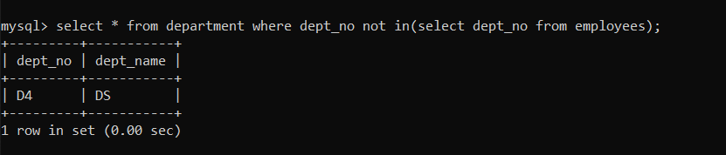

7.Find the employees who earn the maximum salary in each job type. Sort in descending order of salary.

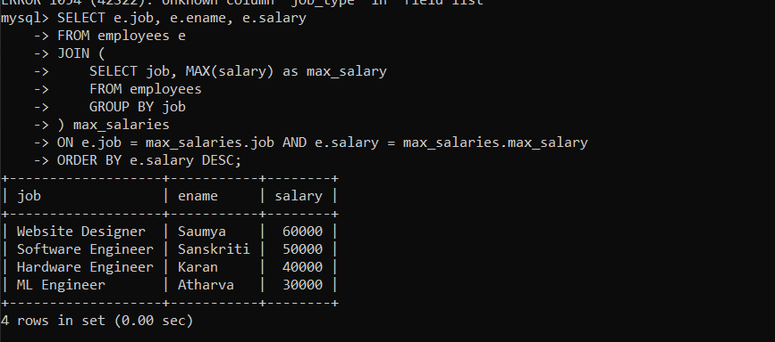

8.In which year did most people joined the company? Display the year and number of employees.

9.Display the details of those employees who earn greater than average of their department.

11.Display all employees hired during 1983. those employees who earn greater than average of their department.

12.Update the salaries of all employees in marketing department & hike it by 15%.

13.Get the gross salaries of all the employees.

14.Get the names of employees and their manager’s name.

15.Display the name, location and department name of all the employees earning more than 1500.

16.Show all the employees in LOC1.

17.List the employees name, job, salary, grade, and department for employees in the company except clerks. Sort on employee names.

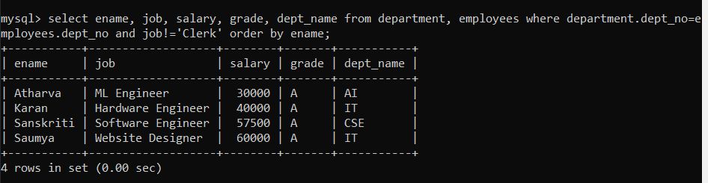

18.Find the employees who earns the minimum salary for their job. Sort in descending order of salary.

19.Find the most recently hired employees in the department order by hiredate.

20.Find out the difference between highest and lowest salaries.

